LOT  012345 | hola  jadksdjlkajdl  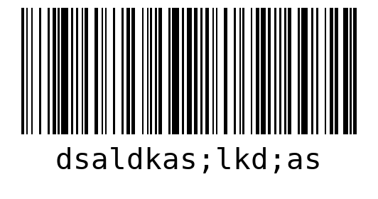  WO 01  LOT 012345  QTY 15
fgsedgdhfd
hfdfghfg
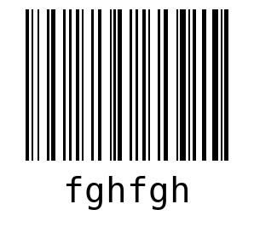
WO 03
LOT 012345
QTY 30

SHEET  1 | hola  jadksdjlkajdl  WO 01  LOT 012345
hola  jadksdjlkajdl  WO 01  LOT 012345 | hola  jadksdjlkajdl  WO 01  LOT 012345
hola  jadksdjlkajdl  WO 01  LOT 012345 | hola  jadksdjlkajdl  WO 01  LOT 012345

hola  jadksdjlkajdl  WO 01  LOT 012345 | hola  jadksdjlkajdl  WO 01  LOT 012345
hola  jadksdjlkajdl  WO 01  LOT 012345 | fgsedgdhfd  hfdfghfg  WO 03  LOT 012345
fgsedgdhfd  hfdfghfg  WO 03  LOT 012345 | fgsedgdhfd  hfdfghfg  WO 03  LOT 012345

fgsedgdhfd  hfdfghfg  WO 03  LOT 012345 | fgsedgdhfd  hfdfghfg  WO 03  LOT 012345
SHEET  2 | fgsedgdhfd  hfdfghfg  WO 03  LOT 012345
fgsedgdhfd  hfdfghfg  WO 03  LOT 012345 | fgsedgdhfd  hfdfghfg  WO 03  LOT 012345

fgsedgdhfd  hfdfghfg  WO 03  LOT 012345 | SHEET  3
hola  jadksdjlkajdl  WO 01  LOT 012345 | hola  jadksdjlkajdl  WO 01  LOT 012345
hola  jadksdjlkajdl  WO 01  LOT 012345 | hola  jadksdjlkajdl  WO 01  LOT 012345

hola  jadksdjlkajdl  WO 01  LOT 012345 | fgsedgdhfd  hfdfghfg  WO 03  LOT 012345
fgsedgdhfd  hfdfghfg  WO 03  LOT 012345 | fgsedgdhfd  hfdfghfg  WO 03  LOT 012345
fgsedgdhfd  hfdfghfg  WO 03  LOT 012345 | fgsedgdhfd  hfdfghfg  WO 03  LOT 012345

fgsedgdhfd  hfdfghfg  WO 03  LOT 012345 | fgsedgdhfd  hfdfghfg  WO 03  LOT 012345
fgsedgdhfd  hfdfghfg  WO 03  LOT 012345 | SHEET  4
fgsedgdhfd  hfdfghfg  WO 03  LOT 012345 | fgsedgdhfd  hfdfghfg  WO 03  LOT 012345

fgsedgdhfd  hfdfghfg  WO 03  LOT 012345 | fgsedgdhfd  hfdfghfg  WO 03  LOT 012345
SHEET  5 | fgsedgdhfd  hfdfghfg  WO 03  LOT 012345
fgsedgdhfd  hfdfghfg  WO 03  LOT 012345 | fgsedgdhfd  hfdfghfg  WO 03  LOT 012345

fgsedgdhfd  hfdfghfg  WO 03  LOT 012345 | fgsedgdhfd  hfdfghfg  WO 03  LOT 012345
SHEET  6 | hola  jadksdjlkajdl  WO 01  LOT 012345
hola  jadksdjlkajdl  WO 01  LOT 012345 | fgsedgdhfd  hfdfghfg  WO 03  LOT 012345

fgsedgdhfd  hfdfghfg  WO 03  LOT 012345 | fgsedgdhfd  hfdfghfg  WO 03  LOT 012345
fgsedgdhfd
hfdfghfg
WO 03
LOT 012345

